

**DATA STRUCTURES LAB**

**WEEK-3**

**Name**  : **ABHISHEK KUMAR JHA**

**Roll no** : **19R21A05C2**

**Date**  : **7/01/2021**

**STACK USING ARRAY:**

#include <stdio.h>

#define size 5

int s[size],i,ch,x,top=-1;

void push();

void pop();

void peak();

void traversal();

int main()

{

printf("1.push\n2.pop\n3.peak\n4.traversal\n");

do

{

printf("\nEnter choice\n");

scanf("%d",&ch);

switch(ch)

{

case 1:push();break;

case 2:pop();break;

case 3:peak();break;

case 4:traversal();break;

}

}while(ch<=4);

}

void push()

{

if(top>=size-1)

printf("Stack Overflow\n");

else

{

printf("Enter data\n");

scanf("%d",&x);

s[++top]=x;

}

}

void pop()

{

if(top==-1)

printf("Stack Underflow\n");

else

{

x=s[top--];

printf("%d is popped\n",x);

}

}

void peak()

{

printf("Top element is %d",s[top]);

}

void traversal()

{

printf("Stack contents are\n");

for(i=top;i>=0;i--)

printf("%d\t",s[i]);

}

**Output:**

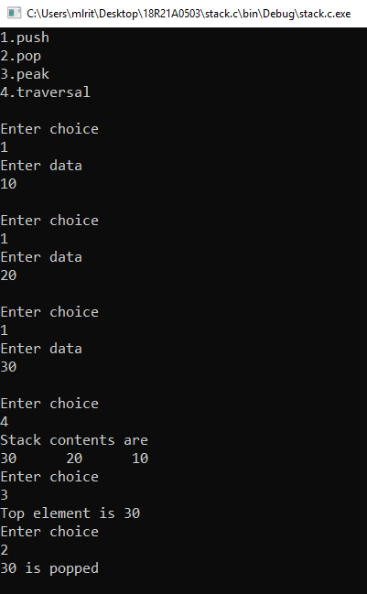

**STACK USING LINKED LIST:**

#include <stdio.h>

#include <stdlib.h>

#define size 5

struct node

{

int data;

struct node *next;

}*n,*temp=NULL,*top=-1;

void push();

void pop();

void peak();

void traversal();

int ch;

int main()

{

printf("1.push\n2.pop\n3.peak\n4.traversal\n");

do

{

printf("\nEnter choice\n");

scanf("%d",&ch);

switch(ch)

{

case 1:push();break;

case 2:pop();break;

case 3:peak();break;

case 4:traversal();break;

}

}while(ch<=4);

}

void push()

{

n=(struct node *)malloc(sizeof(struct node));

printf("Enter data\n");

scanf("%d",&n->data);

n->next=NULL;

if(top==NULL)

top=n;

else

{

n->next=top;

top=n;

}

}

void pop()

{

if(top==NULL)

printf("Stack Underflow\n");

else

{

temp=top;

printf("%d is popped\n",temp->data);

top=top->next;

free(temp);

}

}

void peak()

{

temp=top;

printf("Top element is %d",temp->data);

}

void traversal()

{

temp=top;

while(temp!=NULL)

{

printf("%d->",temp->data);

temp=temp->next;

}

}

**Output:**

